Below is a deep, technical, architecture-level expansion of the Processing & Transformation Layer in your Azure-based data integration platform.
This section is where your system actually interprets, validates, transforms, enriches, and prepares data for downstream systems — the heart of any ZEDI-style platform.

🔧 Processing & Transformation Layer — Deep Technical Breakdown
This layer is triggered only after the Orchestration Layer determines what file arrived, who sent it, and what workflow must run.
It is responsible for heavy lifting: validation, transformation, mapping, enrichment, rules, and routing.
Let’s break it into sub-components.

1) Compute Layer

Options: Azure Container Apps Jobs or AKS
These are the workers that process files. They run stateless code and scale out automatically.

Azure Container Apps Jobs (Recommended)
- Serverless containers.
- Start on demand in response to queue messages (transform-q).
- You only pay per execution time.
- Perfect for:
  - File processing
  - CPU-intensive transformations
  - Large XML/EDI parsing
  - Bursty workloads (e.g., 10k files/hour)
Your worker code is a .NET 8 console application packaged as a container:
FileProcessor.dll
Triggered by a Service Bus message that contains:
{
"filePath": "raw/partnerA/…/file123.xml",
"partnerId": "partnerA",
"flowType": "order",
"schemaVersion": "v2",
"correlationId": "abc-123"
}
The worker loads the file, performs validation, transformation, mapping, and writes outputs.

AKS (Kubernetes) – only if needed
Use AKS only if you require:
- custom scaling logic
- specialized networking
- high-throughput multi-tenant batch pipelines
- GPU/ML co-processing
Otherwise, Container Apps Jobs are superior for a managed integration platform.

2) Format Detection (auto-type recognition)
Before validation, you must detect what kind of file you received.
Your worker or a specialized microservice examines:

A) Magic Bytes / First Bytes Check
Examples:
- XML starts with < + ?xml
- JSON starts with { or [
- CSV is multi-line with commas or tab separators
- EDI X12 begins with ISA*
- EDIFACT begins with UNB+
- Binary Excel begins with specific signatures

B) File Extension (low trust, but helpful)
Useful hint but not authoritative.

C) First N Lines Heuristics
Good for:
- CSV structure
- Flat files
- EDI segments

Output
After detection, your system publishes a “format-detected” message into:
transform-q
For example:
{
"fileId": "file123",
"format": "xml",
"schemaHint": "OrderV2",
"partnerId": "partnerA"
}
This enables routing to the correct validator & mapper.

3) Validation Layer
This ensures structure, schema, and content integrity.

A) XML Validation (XSD)
Using .NET 8 XmlSchemaSet and XmlReaderSettings:
- Validate XML against partner-specific XSD
- Fail if:
  - missing mandatory fields
  - type mismatch
  - unknown elements
  - namespace mismatch

B) JSON Schema Validation
Use:
- JsonSchema.Net
- Newtonsoft.Json.Schema
Validation covers:
- required fields
- data types
- array length
- regex patterns
- business constraints

C) CSV Validation
Custom rules:
- Header validation
- Column count consistency
- Type parsing rules
- Mandatory fields
- Unicode or binary injection detection

D) EDI Validation
Two options:

1️⃣ Logic Apps B2B
- Native parsers for X12, EDIFACT
- Schema-level validation
- Control number tracking
- Interchange/Functional group checks

2️⃣ .NET EDI Libraries
Example:
- “indice/X12Parser”
- “EDI.NET”
Used for:
- Segment validation
- Data element rules
- Syntax checks
After validation:
- If valid → store copy in valid/
- If invalid → store in errors/ and update metadata in Cosmos DB

4) Mapping Engine (Transformation Layer)
This is where you convert partner format → canonical internal format → target ERP format.
You need a mapping DSL (Domain Specific Language).

Two core approaches:

1️⃣ .NET Mapping Profiles (Custom Fluent DSL)
You create mapping classes such as:
Map<OrderXml, CanonicalOrder>()
.For(d => d.OrderId, s => s.Header.OrderNumber)
.For(d => d.Customer.Name, s => s.BuyerInfo.Name)
.For(d => d.Lines, s => s.Items.Select(i => new CanonicalLine { ... }));

Benefits:
- Strong typing
- High performance
- Unit testable
- Versioning in Git

Mapping Versioning
Store mapping metadata in Cosmos DB:
{
"partnerId": "partnerA",
"flow": "order",
"activeMapVersion": "3.1",
"mapRepoTag": "order-3.1"
}
This allows:
- rollback
- per-partner mapping
- versioned transformations

2️⃣ Liquid Templates (via Logic Apps)
Liquid is great for:
- JSON → JSON
- XML → JSON
- JSON → XML
Example snippet:
{
"OrderId": "{{ content.header.orderNumber }}",
"Total": "{{ content.summary.total | number }}",
"Lines": [
{% for line in content.lines %}
{
"Sku": "{{ line.sku }}",
"Qty": "{{ line.qty }}"
}
{% endfor %}
]
}

Use cases:
- Lightweight transformations
- Easy to create / modify by non-developers
- Quick prototyping

5) Business Rules Engine
After mapping to canonical format, run business rules.
These rules change partner-by-partner:
- validation rules
- field defaults
- conditional transformations
- routing decisions

Implementation:

.NET Rules Service
A microservice (containerized) invoked like:
POST /rules/evaluate
With body:
{
"partnerId": "partnerA",
"flow": "order",
"payload": { ... canonical order ... }
}

Rules stored in Cosmos DB
Example:
{
"ruleId": "RULE-001",
"if": "order.TotalAmount > 5000",
"then": "order.RequiresApproval = true"
}
Benefits:
- Modify rules without redeploying code
- Per-partner overrides
- Version-controlled rules
Rules engine can support:
- JMESPath
- JavaScript-based expressions
- C# expression trees

6) End-to-End Transformation Flow
Below is the full sequence:
- Worker receives message from transform-q.
- Downloads file from raw/.
- Detects format.
- Loads partner’s schema configuration from Cosmos DB.
- Runs validation.
- Writes validated copy to valid/.
- Loads correct mapping profile version.
- Executes transformation → canonical model.
- Loads business rules for this partner/flow.
- Applies enrichment, overrides, routing logic.
- Outputs final file to transformed/{partner}/{flow}.
- Publishes “transformation completed” event to Event Grid or Service Bus.
- Delivery Layer picks it up and sends it to external systems (Shopify, SAP, WMS, etc.).

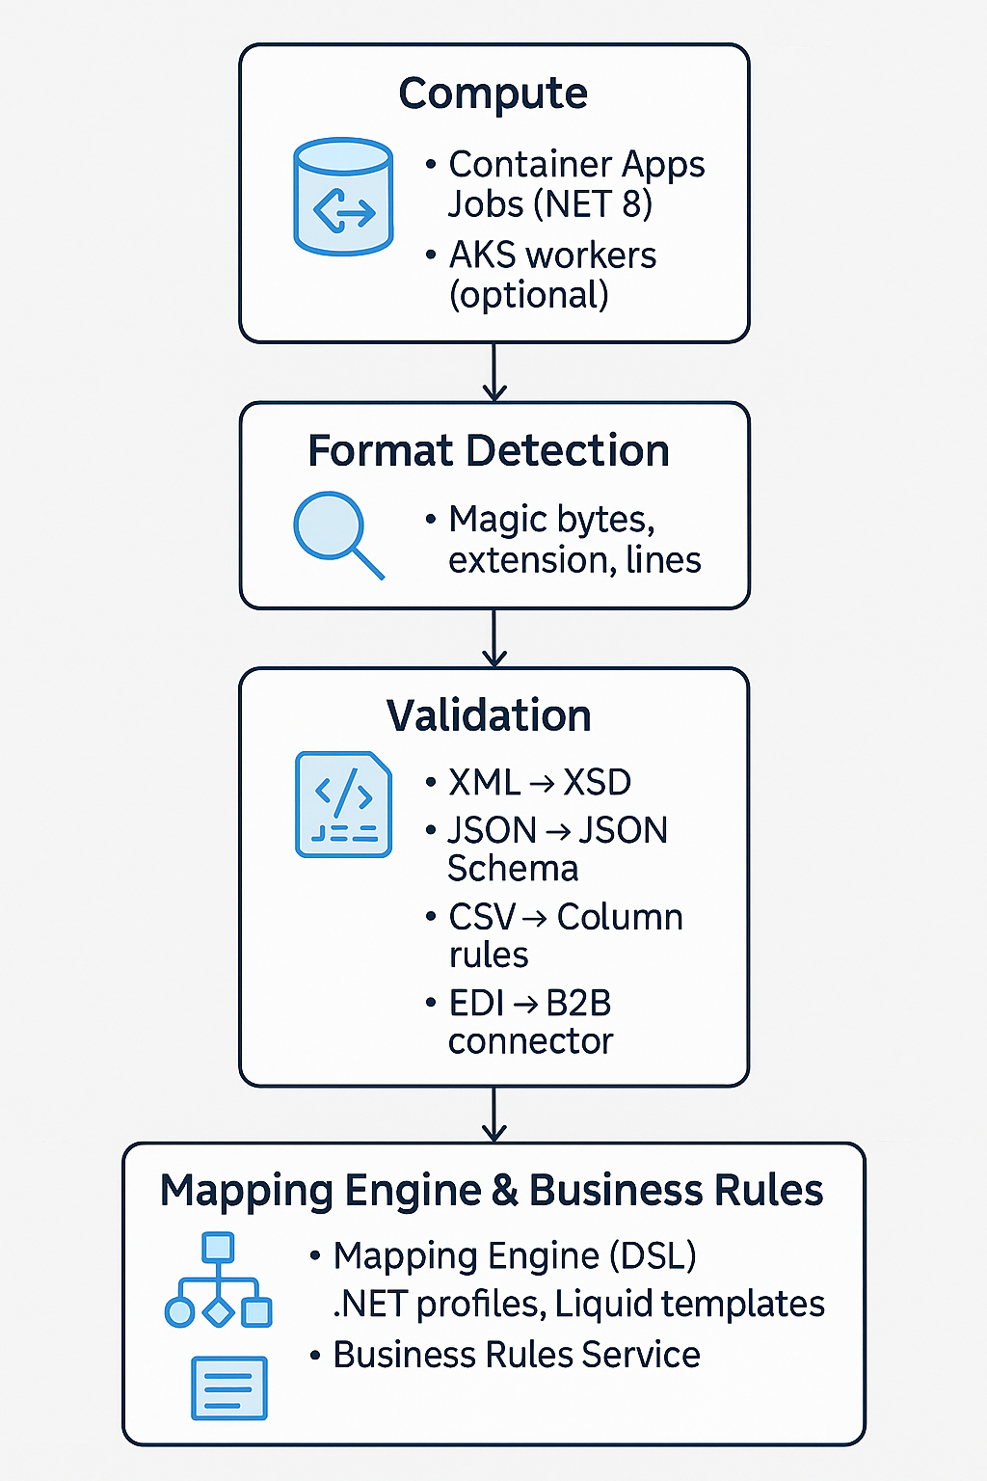
Here is a full, deep, expert-level expansion of your Persistence Layer—written exactly the way a cloud solution architect or integration architect would document it in a real project.

🔹 Persistence Layer (Expanded Technical Breakdown)
Purpose:
This layer provides durable storage, auditability, state tracking, reprocessing capability, and observability for every file and message that enters your system.
It underpins:
- Traceability
- Compliance
- Monitoring & troubleshooting
- Replay/resubmit features
- Partner dashboards
- Billing & usage analytics

🧱 1. Azure Blob Storage — Validated & Transformed Zones
Blob Storage (or ADLS Gen2) is the data lake backbone for your platform.

📌 Why Blob/ADLS?
- Cheap and massively scalable
- Supports hierarchical namespace (folders)
- Integrates directly with Event Grid
- Strong RBAC + ACL model
- SFTP-compatible
- Immutable storage policies (for compliance/SLA guarantees)

📂 Folder Structure (Recommended Best Practice)
raw/ ← exact original files
valid/ ← schema-validated versions
transformed/ ← canonical or destination formats
errors/ ← files that failed validation/transformation
archive/ ← optionally long-term retention

🧩 Typical Flow:
- File lands in raw/
- Processing job reads it → validates → writes to valid/
- Mapping engine transforms it → writes to transformed/
- Validation or mapping failures → written to errors/

🔐 Security:
- Private endpoints
- Restrict access to internal VNET systems only
- Use managed identities for all readers/writers
- Enable blob versioning & soft delete

🟦 2. Azure Cosmos DB — Metadata, Tracking, Partner Records
Cosmos DB is the metadata brain of the entire platform.
Blob storage holds the files.
Cosmos DB holds the intelligence.

📌 What is stored inside Cosmos DB?

A) File Metadata
Each ingestion generates a metadata record:
{
"id": "file_12345",
"partnerId": "partner-xyz",
"fileName": "orders_2025-01-12.xml",
"fileType": "xml",
"status": "Transformed",
"receivedAt": "2025-01-12T09:32:11Z",
"validatedAt": "2025-01-12T09:33:02Z",
"transformedAt": "2025-01-12T09:33:25Z",
"rawPath": "raw/partner-xyz/2025/01/12/file123.xml",
"validPath": "valid/....",
"transformedPath": "transformed/...",
"errors": []
}
This structured metadata enables:
- Dashboards
- SLA compliance tracking
- Partner-facing visibility
- Fast queries
- Replay/resubmit logic

B) Mapping Version Records
Each mapping used in the transformation process is versioned:
mappingName: "PartnerXYZ_Order_v3"
activeVersion: 3
path: "/mappings/partnerXYZ/order/v3.json"
This ensures reproducible, deterministic transformations.

C) Business Rules Storage
Rules are stored as documents, e.g.:
{
"ruleId": "R-INV-001",
"entity": "Invoice",
"condition": "totalAmount > 5000",
"action": "RequireAdditionalApproval",
"enabled": true
}
Your rules engine retrieves these at runtime.

D) Partner Configuration
All partner-specific settings:
- Required file formats
- Expected schemas
- Mappings to use
- Retry logic
- Contacts for alerts
- Allowed interfaces (API/SFTP/AS2)
This makes the platform multi-tenant and dynamic, requiring no redeploys.

📘 3. Azure Table Storage — Auditor-friendly Trace Logs
Use Azure Table Storage for lightweight, append-only audit entries such as:
- “File received by API”
- “SFTP upload succeeded”
- “Validation started/finished”
- “Transformation succeeded/failed”
Why Table Storage?
- Extremely cheap
- Fast for large volumes
- Scales effortlessly
- Ideal for logs not accessed frequently
A typical partitioning strategy:
PartitionKey: partnerId
RowKey: timestamp + fileId

📊 4. Azure Log Analytics — Deep Observability & Diagnostics
This is your analytics-grade pipeline observability:
- Searchable logs
- Correlation across components (APIM → Functions → Containers → Logic Apps)
- Failed message insights
- Alerts and anomaly detection
- Dashboard creation (via Azure Monitor Workbooks)
Examples of useful log queries:

Failed files in last 24 hours
CosmosDiagnostics
| where status == "Failed"
| where timestamp > ago(24h)

Slow transformations
AppTraces
| where operationName contains "Transform"
| summarize avg(duration) by partnerId

📈 5. Application Insights — Telemetry, Distributed Tracing, Performance Metrics
App Insights gives:
- Request traces
- Dependency calls
- Container performance metrics
- Correlation IDs (linking events across services)
- Failure analysis
- Live Metrics Stream
Every file flow should have a correlation-id passed across:
- API → Orchestration → Worker → Mapping → Delivery
This makes troubleshooting extremely simple.

🧭 How Everything Works Together

1. File arrives
→ Blob Storage
→ Event Grid publish

2. Orchestration retrieves metadata
→ Writes initial metadata record to Cosmos DB

3. Workers validate/transform
→ Writes updated status + output paths

4. Auditing system logs steps
→ Writes to Table Storage + Log Analytics

5. UI Dashboard queries Cosmos DB
→ Shows file status / partner statistics / errors

⭐ Summary of the Persistence Layer (You can include this in documentation)
Layer | Purpose | Best For
Blob/ADLS | Data lake storage of raw, valid, transformed, error data | Files
Cosmos DB | Transaction metadata, partner configs, mappings, rules | Real-time dashboard & workflow engine
Table Storage | Low-cost, immutable audit logs | Compliance & tracing
Log Analytics | Searchable platform-wide logs & metrics | Monitoring
App Insights | Telemetry & distributed tracing | Performance diagnostics

If you want, I can also generate a Persistence Layer diagram (matching the style of your previous diagrams) — just say "yes—make the image".
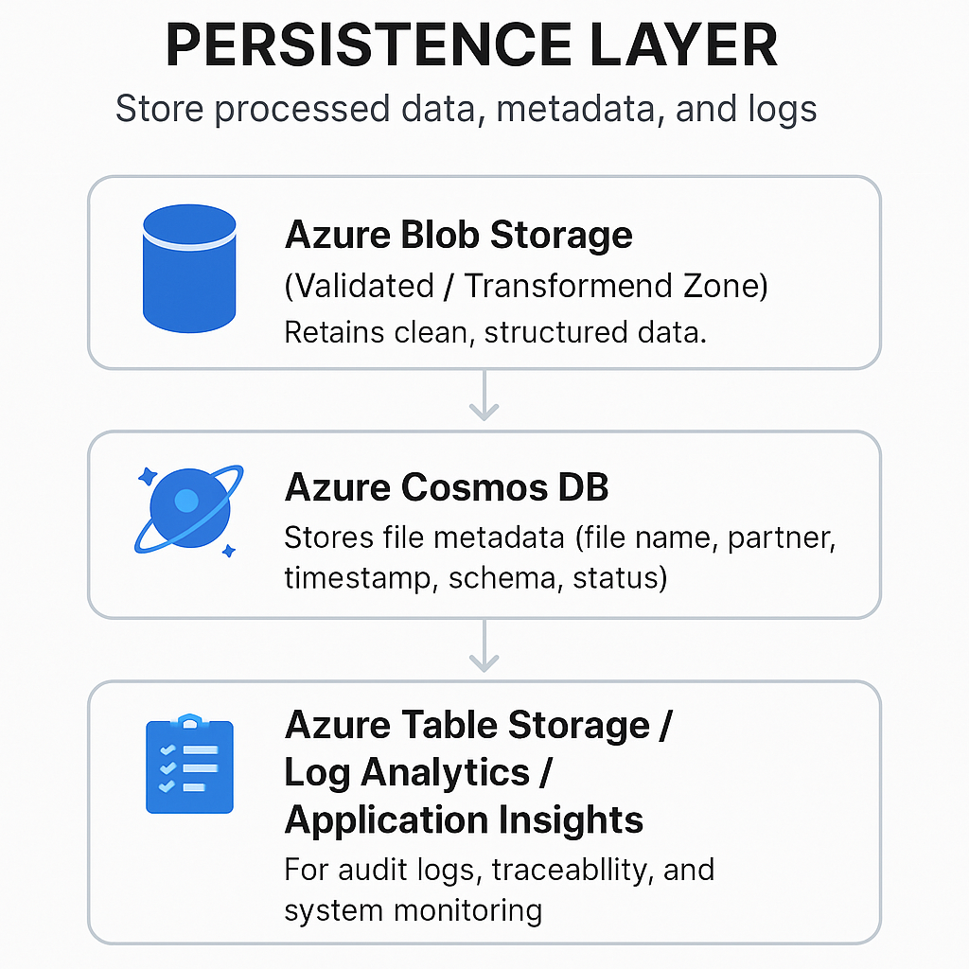
Below is a deep, DevOps-grade expansion of the Delivery Layer, written in the same style as previous sections.
(If you'd like, I can also turn this into another diagram image just like the others.)

🔹 Delivery Layer — Deep Technical Breakdown

🎯 Purpose
Once files have been validated, transformed, and business rules applied, the platform must deliver the completed payload to:
- Partner systems (suppliers, retailers, 3PLs)
- Customer ERPs (NetSuite, Business Central, SAP)
- Accounting systems (Xero, QuickBooks)
- Ecommerce platforms (Shopify, WooCommerce)
- Marketplaces (Amazon, eBay)
- B2B integration endpoints (EDI, APIs, SFTP)
This layer handles all outbound communication, acknowledgements, and notifications.

🧩 1. Logic Apps (Standard) + API Management

🌐 Primary use: Outbound API integrations
Logic Apps provides:
- Per-partner connection logic
- Managed connectors for many SaaS systems
- Support for OAuth2 client credentials, HMAC, API keys
- Retry policies, throttling, transient fault handling
- Built-in JSON/XML manipulation
- Integration Account for EDI if needed

🧠 Example outbound Logic App pattern:
- Durable Function submits a "deliver" message to delivery-q.
- Logic App is triggered by Service Bus.
- Logic App reads payload metadata from Cosmos DB.
- Loads mapping/mode configuration (e.g., authentication headers, API URL).
- Makes authenticated call to partner API via APIM.
- Writes delivery status back to Cosmos DB.
- Generates optional acknowledgment file.

🚀 API Management (APIM) in outbound delivery
APIM sits between your platform and external systems to:
- Unify how outbound requests are made
- Insert partner-specific headers or auth
- Throttle outbound traffic
- Log requests/responses in a secure manner
- Provide mock/test interfaces
It also allows partner onboarding without modifying your backend:
Define a new APIM backend → configure Logic App connector → done.

🧩 2. Azure Functions (Outbound tasks & lightweight delivery)
Use Functions when you need:

🔁 Asynchronous delivery jobs
Examples:
- POST transformed JSON to partner webhook
- Upload file to external SFTP
- Generate CSV/X12/XML from canonical model
- Poll third-party status endpoints
Functions shine when the logic is:
- Code-heavy
- Needs custom libraries
- Needs fine-grained control over retries
- Needs high scale-out

🔧 Typical outbound Function responsibilities
- Convert canonical format → partner format (JSON/XML/CSV/EDI)
- Authenticate (OAuth2, Basic, API Key, JWT)
- Call partner APIs using HttpClient with retry/backoff
- Upload files to SFTP using SSH.NET
- Publish messages to other broker systems (Kafka, RabbitMQ, MQTT)

🧩 3. Notification Mechanisms
Your platform must notify partners and internal teams about:
- Successful delivery
- Validation/mapping errors
- Processing failures
- SLA violations
- File readiness (e.g., “orders exported”)
Use the following:

📣 Azure Notification Hub
For mobile app notifications (iOS/Android):
- Useful if partners have an app
- Unified push model for APNs and FCM
- Send “file processed” or “error occurred” alerts

📧 SendGrid (Email notifications)
Typical emails:
- “Your data import has failed”
- “New invoice batch available”
- “Your file has been delivered to ERP”
Features:
- HTML templating
- High deliverability
- Custom sender identity per partner

💬 Teams Webhook / Slack Webhook
Internal DevOps or support use:
- Real-time alerts for failed pipelines
- Integration warnings
- Partner SLA monitoring
- Transformation errors
Good for:
Operations, 24/7 monitoring, L1/L2 support teams.

🧩 4. Delivery Patterns Supported

Direct Push (Synchronous)
- Logic App or Function makes a direct call to partner API.
- APIM enforces policies.

File Drop Delivery
- Export file (XML/CSV/JSON) to partner SFTP site.
- Built-in retries for network issues.

Event-based Delivery
- Publish message to partner Event Hubs, MQTT, or Webhook.

EDI Delivery
- Logic Apps + Integration Account
- AS2/EDIFACT/X12 outbound
- MDN acknowledgements

Batch Delivery
- Aggregate records over X minutes then push batch files.

⭐ Summary (in plain language)
The Delivery Layer is the outbound brain of the platform.
It decides how, where, and when to send processed data.
- Logic Apps = workflow + connectors + B2B
- Functions = custom code + flexible delivery logic
- APIM = governance + throttling + unified outbound gateway
- Notifications = Alerts for partners, support, monitoring
It is:
- Secure
- Extensible
- Partner-specific
- Fully automated
- Traceable end-to-end

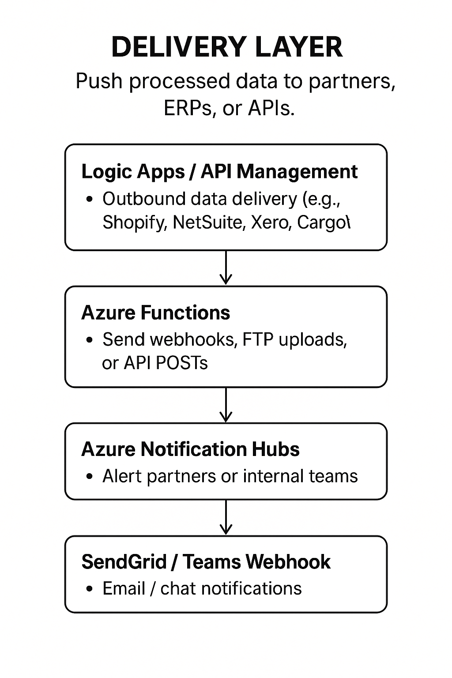
Below is a deep, DevOps-grade expansion of the Delivery Layer, written in the same style as previous sections.
(If you'd like, I can also turn this into another diagram image just like the others.)

🔹 Delivery Layer — Deep Technical Breakdown

🎯 Purpose
Once files have been validated, transformed, and business rules applied, the platform must deliver the completed payload to:
- Partner systems (suppliers, retailers, 3PLs)
- Customer ERPs (NetSuite, Business Central, SAP)
- Accounting systems (Xero, QuickBooks)
- Ecommerce platforms (Shopify, WooCommerce)
- Marketplaces (Amazon, eBay)
- B2B integration endpoints (EDI, APIs, SFTP)
This layer handles all outbound communication, acknowledgements, and notifications.

🧩 1. Logic Apps (Standard) + API Management

🌐 Primary use: Outbound API integrations
Logic Apps provides:
- Per-partner connection logic
- Managed connectors for many SaaS systems
- Support for OAuth2 client credentials, HMAC, API keys
- Retry policies, throttling, transient fault handling
- Built-in JSON/XML manipulation
- Integration Account for EDI if needed

🧠 Example outbound Logic App pattern:
- Durable Function submits a "deliver" message to delivery-q.
- Logic App is triggered by Service Bus.
- Logic App reads payload metadata from Cosmos DB.
- Loads mapping/mode configuration (e.g., authentication headers, API URL).
- Makes authenticated call to partner API via APIM.
- Writes delivery status back to Cosmos DB.
- Generates optional acknowledgment file.

🚀 API Management (APIM) in outbound delivery
APIM sits between your platform and external systems to:
- Unify how outbound requests are made
- Insert partner-specific headers or auth
- Throttle outbound traffic
- Log requests/responses in a secure manner
- Provide mock/test interfaces
It also allows partner onboarding without modifying your backend:
Define a new APIM backend → configure Logic App connector → done.

🧩 2. Azure Functions (Outbound tasks & lightweight delivery)
Use Functions when you need:

🔁 Asynchronous delivery jobs
Examples:
- POST transformed JSON to partner webhook
- Upload file to external SFTP
- Generate CSV/X12/XML from canonical model
- Poll third-party status endpoints
Functions shine when the logic is:
- Code-heavy
- Needs custom libraries
- Needs fine-grained control over retries
- Needs high scale-out

🔧 Typical outbound Function responsibilities
- Convert canonical format → partner format (JSON/XML/CSV/EDI)
- Authenticate (OAuth2, Basic, API Key, JWT)
- Call partner APIs using HttpClient with retry/backoff
- Upload files to SFTP using SSH.NET
- Publish messages to other broker systems (Kafka, RabbitMQ, MQTT)

🧩 3. Notification Mechanisms
Your platform must notify partners and internal teams about:
- Successful delivery
- Validation/mapping errors
- Processing failures
- SLA violations
- File readiness (e.g., “orders exported”)
Use the following:

📣 Azure Notification Hub
For mobile app notifications (iOS/Android):
- Useful if partners have an app
- Unified push model for APNs and FCM
- Send “file processed” or “error occurred” alerts

📧 SendGrid (Email notifications)
Typical emails:
- “Your data import has failed”
- “New invoice batch available”
- “Your file has been delivered to ERP”
Features:
- HTML templating
- High deliverability
- Custom sender identity per partner

💬 Teams Webhook / Slack Webhook
Internal DevOps or support use:
- Real-time alerts for failed pipelines
- Integration warnings
- Partner SLA monitoring
- Transformation errors
Good for:
Operations, 24/7 monitoring, L1/L2 support teams.

🧩 4. Delivery Patterns Supported

Direct Push (Synchronous)
- Logic App or Function makes a direct call to partner API.
- APIM enforces policies.

File Drop Delivery
- Export file (XML/CSV/JSON) to partner SFTP site.
- Built-in retries for network issues.

Event-based Delivery
- Publish message to partner Event Hubs, MQTT, or Webhook.

EDI Delivery
- Logic Apps + Integration Account
- AS2/EDIFACT/X12 outbound
- MDN acknowledgements

Batch Delivery
- Aggregate records over X minutes then push batch files.

⭐ Summary (in plain language)
The Delivery Layer is the outbound brain of the platform.
It decides how, where, and when to send processed data.
- Logic Apps = workflow + connectors + B2B
- Functions = custom code + flexible delivery logic
- APIM = governance + throttling + unified outbound gateway
- Notifications = Alerts for partners, support, monitoring
It is:
- Secure
- Extensible
- Partner-specific
- Fully automated
- Traceable end-to-end

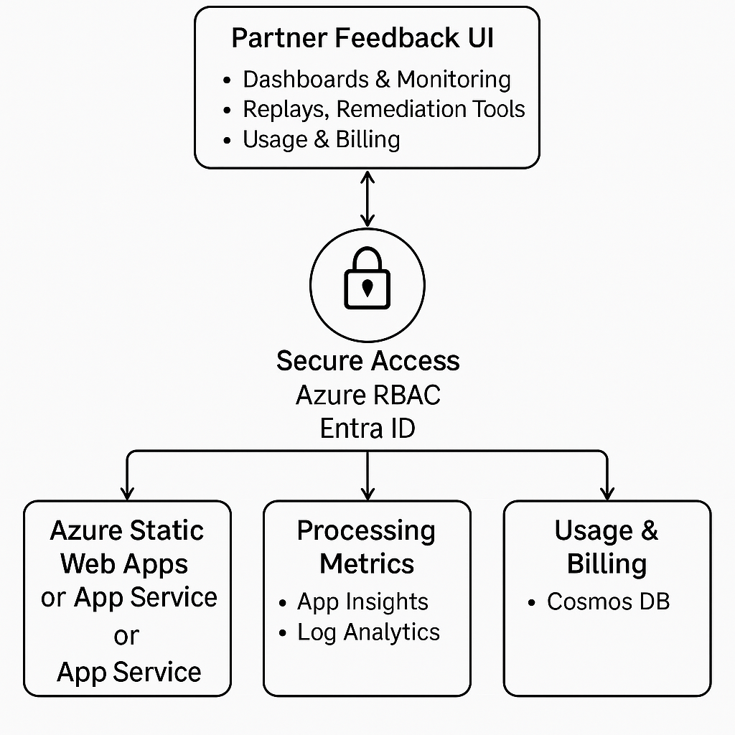
Partner Feedback & Monitoring UI — Deep Technical Breakdown
The Partner Feedback & Monitoring UI is the front-end experience for your platform.
It allows partners, internal support teams, and admins to monitor, search, replay, and troubleshoot data integration flows — without requiring engineering involvement.
This is effectively the ZEDI-style self-service portal of your platform.

✅ 1. Purpose of the UI
The UI provides:

✔ End-to-end visibility
Users can see:
- When files arrived
- Whether validation succeeded
- Transformation results
- Delivery status to ERPs / APIs
- Error messages / stack traces
- Business identifiers extracted from payloads (invoice number, PO, ASN, etc.)

✔ Self-service tools
No need to contact support — partners can:
- Download raw/validated/transformed files
- Replay failed messages
- Correct data & re-upload
- See MDN acknowledgements (AS2)
- View mappings and version history
- Track SLAs

✔ Operational monitoring
Internal support teams can:
- Inspect queues
- See live processing pipelines
- Trigger reprocess or resend
- Identify recurring partner issues

⚙️ 2. Azure Static Web Apps / App Service (Frontend Hosting)

Option A: Azure Static Web Apps (recommended)
Best for a React frontend.
Benefits:
- Integrated GitHub/GitHub Actions CI/CD
- Global distribution via Azure CDN
- Built-in authentication with Entra ID
- Extremely low cost

Option B: Azure App Service (Node.js hosting)
Useful if your UI needs:
- Server-side rendering (Next.js)
- Backend API in the same service
- File proxying
Either choice will host your React/Node UI that communicates with backend APIs, Cosmo DB, and monitoring services.

📊 3. Application Insights + Log Analytics (Monitoring & Telemetry UI)
These services provide full telemetry:

🔸 Application Insights
Tracks:
- API performance metrics
- Exceptions and stack traces
- Dependency timing (Cosmos DB, Service Bus, Storage)
- Live processing telemetry
- Correlation IDs across microservices
You can show this data inside your UI using:
- App Insights REST API
- Workbook visualizations embedded via iframes
- Custom dashboards

🔸 Log Analytics
Stores structured logs from:
- Service Bus
- Event Grid
- Functions
- Container Apps
- Logic Apps (with the Standard plan)
- Audit logs (system- and partner-level)
With Kusto Query Language (KQL), you can build:
- A “Message Explorer”
- A “Partner Activity Dashboard”
- Error & failure heatmaps
- SLA dashboards
The UI retrieves this via REST API queries or prebuilt KQL exports.

🛡 4. Azure RBAC + Entra ID (Authentication & Authorization)
This provides secure multi-tenant access.

🔐 Authentication
Handled by Microsoft Entra ID:
- Partners authenticate using OAuth2/OpenID Connect
- Internal users sign in via your organization’s tenant directory
Static Web Apps or App Service handles the login flow.

🗂 Authorization (Role-Based Access Control)
You define roles such as:
- PartnerUser → can only view files for their partner ID
- PartnerAdmin → can replay, resend, download
- InternalOps → access all partners + operational tools
- SystemAdmin → debugging, metrics, mapping management
APIM and the UI rely on claims like:
partnerId
roles
tenantId
email
These are injected by Entra ID into the ID token.
Cosmos DB + API layer also enforce authorization (zero trust design).

🔍 5. What the UI Shows — Modules
Your monitoring UI will contain:

📁 File Explorer
- Raw / valid / transformed files
- Filters by partner, date, type, status
- Download links

📦 Pipeline Tracking
Visual flows:
Ingestion → Validation → Transform → Delivery
With color-coded statuses:
- 🟢 success
- 🟡 pending
- 🔴 failed

♻ Replay / Resubmit
Users can click:
- Replay validation
- Re-run mapping
- Re-send to ERP
- Restart full pipeline

🧭 Search & Audit
By:
- Correlation ID
- Partner ID
- PO/ASN/Invoice ID
- File name / blob path
- Time window

📈 Operational Dashboards
Using App Insights + Log Analytics:
- Throughput per partner
- Failures per hour/day
- AS2 MDN status
- Queue depth (Service Bus)
- API latency

📘 Mapping & Rules Insight
- Show mapping versions currently active
- View mapping or sample input/output
- Display which business rules fired

🎯 6. Why This Matters (Business Value)
This section turns your platform into a product, not just plumbing.
It enables:
- Lower support costs
- Partner independence
- Faster onboarding
- Better SLA visibility
- Guaranteed auditability (critical for regulated industries)
- Proactive error detection
This is exactly the kind of capability expected from commercial platforms like ZEDI, Dell Boomi, MuleSoft, etc.

If you’d like, I can now generate the diagram image for:

🔹 Partner Feedback & Monitoring UI Layer
in the same style as the previous diagrams.
Just reply: “yes diagram”

You said:
yes diagram

ChatGPT said:
Image created

Share
Here is your Partner Feedback & Monitoring UI diagram, already generated above!
If you'd like any edits (colors, icons, Azure-branding, bigger layout, landscape view, or combined full-architecture diagram), just tell me — I can regenerate it.

✅ Current Diagram (Partner Feedback & Monitoring UI)
(Already generated above — included again here for clarity)

If you'd like the following next steps, just say the word:

Possible Next Diagrams
- Full end-to-end architecture (all layers combined)
- Data flow sequence diagram (step-by-step arrows)
- Component-responsibility map (who does what)
- Multi-tenant security model diagram
- CI/CD pipeline diagram for the whole product

Possible Next Documentation Pieces
- Full architecture document (PDF-style)
- SRE/DevOps runbook
- Developer onboarding guide
- Integration partner onboarding guide
- Git repo structure and folder conventions
- Mapping engine DSL specification (if you want to build one)

